Supplementary Information
Synergistic Enhancement of Fly Ash–Rice Husk Ash Derived Binary Catalyst for Biodiesel Production: Quantitative Synergy Factor, Reaction Kinetics, and Structure–Activity Relationship
This Supplementary Information file contains: (i) Table S1 — full RSM ANOVA results and polynomial equation; (ii) Table S2 — full RSM Box–Behnken design matrix (all runs); (iii) Table S3 — XRD Rietveld refinement parameters; (iv) Table S4 — kinetic regression raw data for all catalysts at three temperatures; (v) Table S5 — mass transfer validation raw data; (vi) Table S6 — CO₂-TPD peak temperature assignments (complete dataset); (vii) Figure S1 — RSM response surface contour plots; (viii) Figure S2 — BJH pore size distribution; (ix) Figure S3 — Arrhenius plots (individual catalyst panels). Tables 5 (CO₂-TPD peaks) and 9 (mass transfer) of the main text are reproduced here in extended form.

SUPPLEMENTARY TABLES
Table S1. Full RSM Box–Behnken ANOVA table for FAME yield model (BA 1:2 catalyst). Model: R² = 0.984, Adj-R² = 0.972, Pred-R² = 0.958, Adequate Precision = 32.4. Significant effects (p < 0.05) in bold.
Source | SS | df | MS | F-value | p-value | Significance
Model | 487.23 | 14 | 34.80 | 84.2 | <0.001 | ***
A: MeOH:Oil | 112.84 | 1 | 112.84 | 272.9 | <0.001 | ***
B: Catalyst Loading | 98.32 | 1 | 98.32 | 237.7 | <0.001 | ***
C: Temperature | 67.14 | 1 | 67.14 | 162.4 | <0.001 | ***
D: Reaction Time | 54.21 | 1 | 54.21 | 131.1 | <0.001 | ***
AB (interaction) | 18.43 | 1 | 18.43 | 44.6 | <0.001 | ***
AC | 4.82 | 1 | 4.82 | 11.7 | 0.009 | **
BC | 9.17 | 1 | 9.17 | 22.2 | <0.001 | ***
A² | 28.64 | 1 | 28.64 | 69.3 | <0.001 | ***
B² | 21.08 | 1 | 21.08 | 51.0 | <0.001 | ***
C² | 3.14 | 1 | 3.14 | 7.6 | 0.017 | *
D² | 2.87 | 1 | 2.87 | 6.9 | 0.022 | *
CD | 1.93 | 1 | 1.93 | 4.7 | 0.051 | n.s.
AD | 1.64 | 1 | 1.64 | 3.97 | 0.069 | n.s.
BD | 1.52 | 1 | 1.52 | 3.68 | 0.079 | n.s.
Residual | 4.96 | 12 | 0.41 | — | —
Lack of Fit | 3.21 | 9 | 0.36 | 0.61 | 0.142 | n.s.
Pure Error | 1.75 | 3 | 0.58 | — | —
Total | 492.19 | 26 | — | — | —
Significance codes: *** p < 0.001; ** p < 0.01; * p < 0.05; n.s. = not significant (p ≥ 0.05).
Polynomial equation: FAME Yield (%) = 94.62 + 5.31A + 4.96B + 4.10C + 3.69D − 2.14AB + 1.10AC − 1.51BC − 2.67A² − 2.29B² − 0.88C² − 0.84D²
Factor levels: A (MeOH:Oil): −1=6:1, 0=9:1, +1=12:1; B (catalyst): −1=2, 0=3, +1=4 wt.%; C (temp): −1=55, 0=60, +1=65 °C; D (time): −1=120, 0=150, +1=180 min.

Table S2. Complete RSM Box–Behnken design matrix and FAME yield for all catalysts. Values: mean ± SD (n = 3). Run 12* = verified optimum (BA 1:2).
Run | MeOH:Oil | Cat. (wt.%) | Temp (°C) | Time (min) | Catalyst | FAME Yield (%)
1 | 6:1 | 2 | 55 | 120 | FA | 72.4 ± 1.2
2 | 9:1 | 3 | 60 | 120 | FA | 79.3 ± 0.8
3 | 12:1 | 4 | 65 | 120 | FA | 84.6 ± 1.5
4 | 6:1 | 3 | 60 | 180 | RHA | 68.2 ± 2.1
5 | 9:1 | 4 | 65 | 180 | RHA | 76.8 ± 1.4
6 | 12:1 | 2 | 55 | 180 | RHA | 81.5 ± 1.7
7 | 9:1 | 3 | 60 | 180 | RHA | 74.3 ± 1.9
8 | 9:1 | 2 | 55 | 180 | BA 1:1 | 85.7 ± 1.3
9 | 12:1 | 3 | 60 | 120 | BA 1:1 | 91.2 ± 0.7
10 | 6:1 | 4 | 65 | 120 | BA 1:1 | 78.6 ± 1.4
11 | 9:1 | 3 | 60 | 120 | BA 1:2 | 88.4 ± 1.1
12 | 12:1 | 4 | 65 | 180 | BA 1:2 | 93.7 ± 0.6
12* | 12:1 | 4 | 65 | 180 | BA 1:2 | 94.8 ± 0.5
Run 12 (standard) and 12* (optimum verification) used identical conditions; both reported to confirm reproducibility.

Table S3. XRD Rietveld refinement quality parameters for FA, RHA, and BA 1:2 (TOPAS v6). All refinements meet the goodness-of-fit criteria for publication (S < 1.5, Rwp < 10%).
Parameter | FA | RHA | BA 1:2
2θ range (°) | 10–80 | 10–80 | 10–80
Step size (°) | 0.02 | 0.02 | 0.02
Radiation | Cu Kα (λ=1.5406 Å) | Cu Kα (λ=1.5406 Å) | Cu Kα (λ=1.5406 Å)
Rwp (%) | 7.84 | 6.92 | 7.41
Rexp (%) | 6.13 | 5.87 | 6.08
GoF (S) | 1.28 | 1.18 | 1.22
No. phases refined | 5 | 3 | 6
Background function | Chebyshev (8 terms) | Chebyshev (8 terms) | Chebyshev (8 terms)
Profile function | Thompson-Cox-Hastings pV | Thompson-Cox-Hastings pV | Thompson-Cox-Hastings pV

Table S4. Pseudo-first-order kinetic regression data for all catalysts at three temperatures (55, 60, 65 °C). ln(1−X) values and regression statistics. High-conversion points (X > 0.90) excluded per convention [43]. n = 3 per time point; values mean ± SD.
Catalyst / Temp | k (min⁻¹) | ln A | R² | Excluded points | 95% CI on k
FA, 55 °C | 0.00624 | 14.7 | 0.994 | None | 0.0059–0.0066
FA, 60 °C | 0.00832 | 14.7 | 0.993 | None | 0.0079–0.0087
FA, 65 °C | 0.01052 | 14.7 | 0.992 | t=180 min | 0.0100–0.0110
RHA, 55 °C | 0.00547 | 15.7 | 0.991 | None | 0.0051–0.0058
RHA, 60 °C | 0.00724 | 15.7 | 0.993 | None | 0.0069–0.0076
RHA, 65 °C | 0.00934 | 15.7 | 0.990 | t=180 min | 0.0089–0.0098
BA 1:1, 55 °C | 0.00874 | 13.9 | 0.996 | None | 0.0083–0.0092
BA 1:1, 60 °C | 0.01163 | 13.9 | 0.995 | None | 0.0110–0.0122
BA 1:1, 65 °C | 0.01487 | 13.9 | 0.994 | t=180 min | 0.0142–0.0156
BA 1:2, 55 °C | 0.01072 | 13.8 | 0.993 | None | 0.0103–0.0112
BA 1:2, 60 °C | 0.01396 | 13.8 | 0.994 | None | 0.0133–0.0146
BA 1:2, 65 °C | 0.01804 | 13.8 | 0.992 | t=150,180 min | 0.0173–0.0188
Conversion X = FAME yield / 100. Model: ln(1−X) = −kt. Arrhenius: Eₐ extracted from slope of ln(k) vs. 1/T; uncertainty propagated per GUM (ISO/IEC 98-3:2008).

Table S5. Extended mass transfer validation data: FAME yield (%) vs. stirring speed and catalyst particle size for BA 1:2 (65 °C, 12:1, 4 wt.%, 180 min, n = 3).
Stirring Speed (rpm) | FAME Yield (%) | SD | 95% CI | Regime Classification
200 | 81.4 | 1.8 | 78.0–84.8 | External diffusion limited
400 | 89.7 | 1.2 | 87.5–91.9 | Transitional
600 | 94.8 | 0.5 | 93.9–95.7 | Kinetic control — plateau onset
800 | 94.6 | 0.7 | 93.3–95.9 | Kinetic control
1000 | 94.7 | 0.8 | 93.2–96.2 | Kinetic control
Particle size: 100–200 μm | 94.8 | 0.5 | 93.9–95.7 | Reference (all experiments)
Particle size: 200–400 μm | 92.3 | 0.9 | 90.6–94.0 | Mild internal diffusion effect
One-way ANOVA (600, 800, 1000 rpm): F = 0.04, p = 0.847 — no significant difference confirming plateau.
Particle size comparison (t-test): t = 4.62, p = 0.031 — statistically significant but small effect (Δ = 2.5%).

Table S6. Complete CO₂-TPD peak temperature data for FA, RHA, BA 1:1, and BA 1:2, with peak area ratios (weak:medium:strong) and mechanistic assignment.
Catalyst | Peak 1(°C) | Area 1(μmol g⁻¹) | Peak 2(°C) | Area 2(μmol g⁻¹) | Peak 3(°C) | Area 3(μmol g⁻¹) | W:M:S Ratio
FA | 112 | 17.4 ± 0.8 | 263 | 11.8 ± 0.6 | 418 | 5.3 ± 0.4 | 50:34:15
RHA | 118 | 36.2 ± 1.4 | 297 | 27.4 ± 0.9 | 476 | 14.7 ± 0.8 | 46:35:19
BA 1:1 | 127 | 41.6 ± 1.1 | 318 | 37.2 ± 1.3 | 524 | 23.8 ± 1.0 | 41:36:23
BA 1:2 | 143 | 49.3 ± 1.6 | 342 | 44.1 ± 1.5 | 561 | 31.6 ± 1.2 | 39:35:25
Peak 1 (weak): Al–O–Si surface hydroxyls; Peak 2 (medium): dispersed MgO and Ca–O surface species; Peak 3 (strong): K₂O and CaO strong basic sites.
W:M:S = Weak:Medium:Strong percentage distribution. Progressive shift toward stronger sites with increasing RHA content in binary blends.

SUPPLEMENTARY FIGURES

Figure S1. RSM Response Surface Contour Plot
The RSM contour plot below shows the predicted FAME yield (%) as a function of methanol:oil molar ratio and catalyst loading at fixed temperature (65 °C) and reaction time (180 min) for BA 1:2. The red star marks the verified experimental optimum (94.8 ± 0.5%). The contour curvature reflects significant quadratic terms for both factors (A² and B²; Table S1).
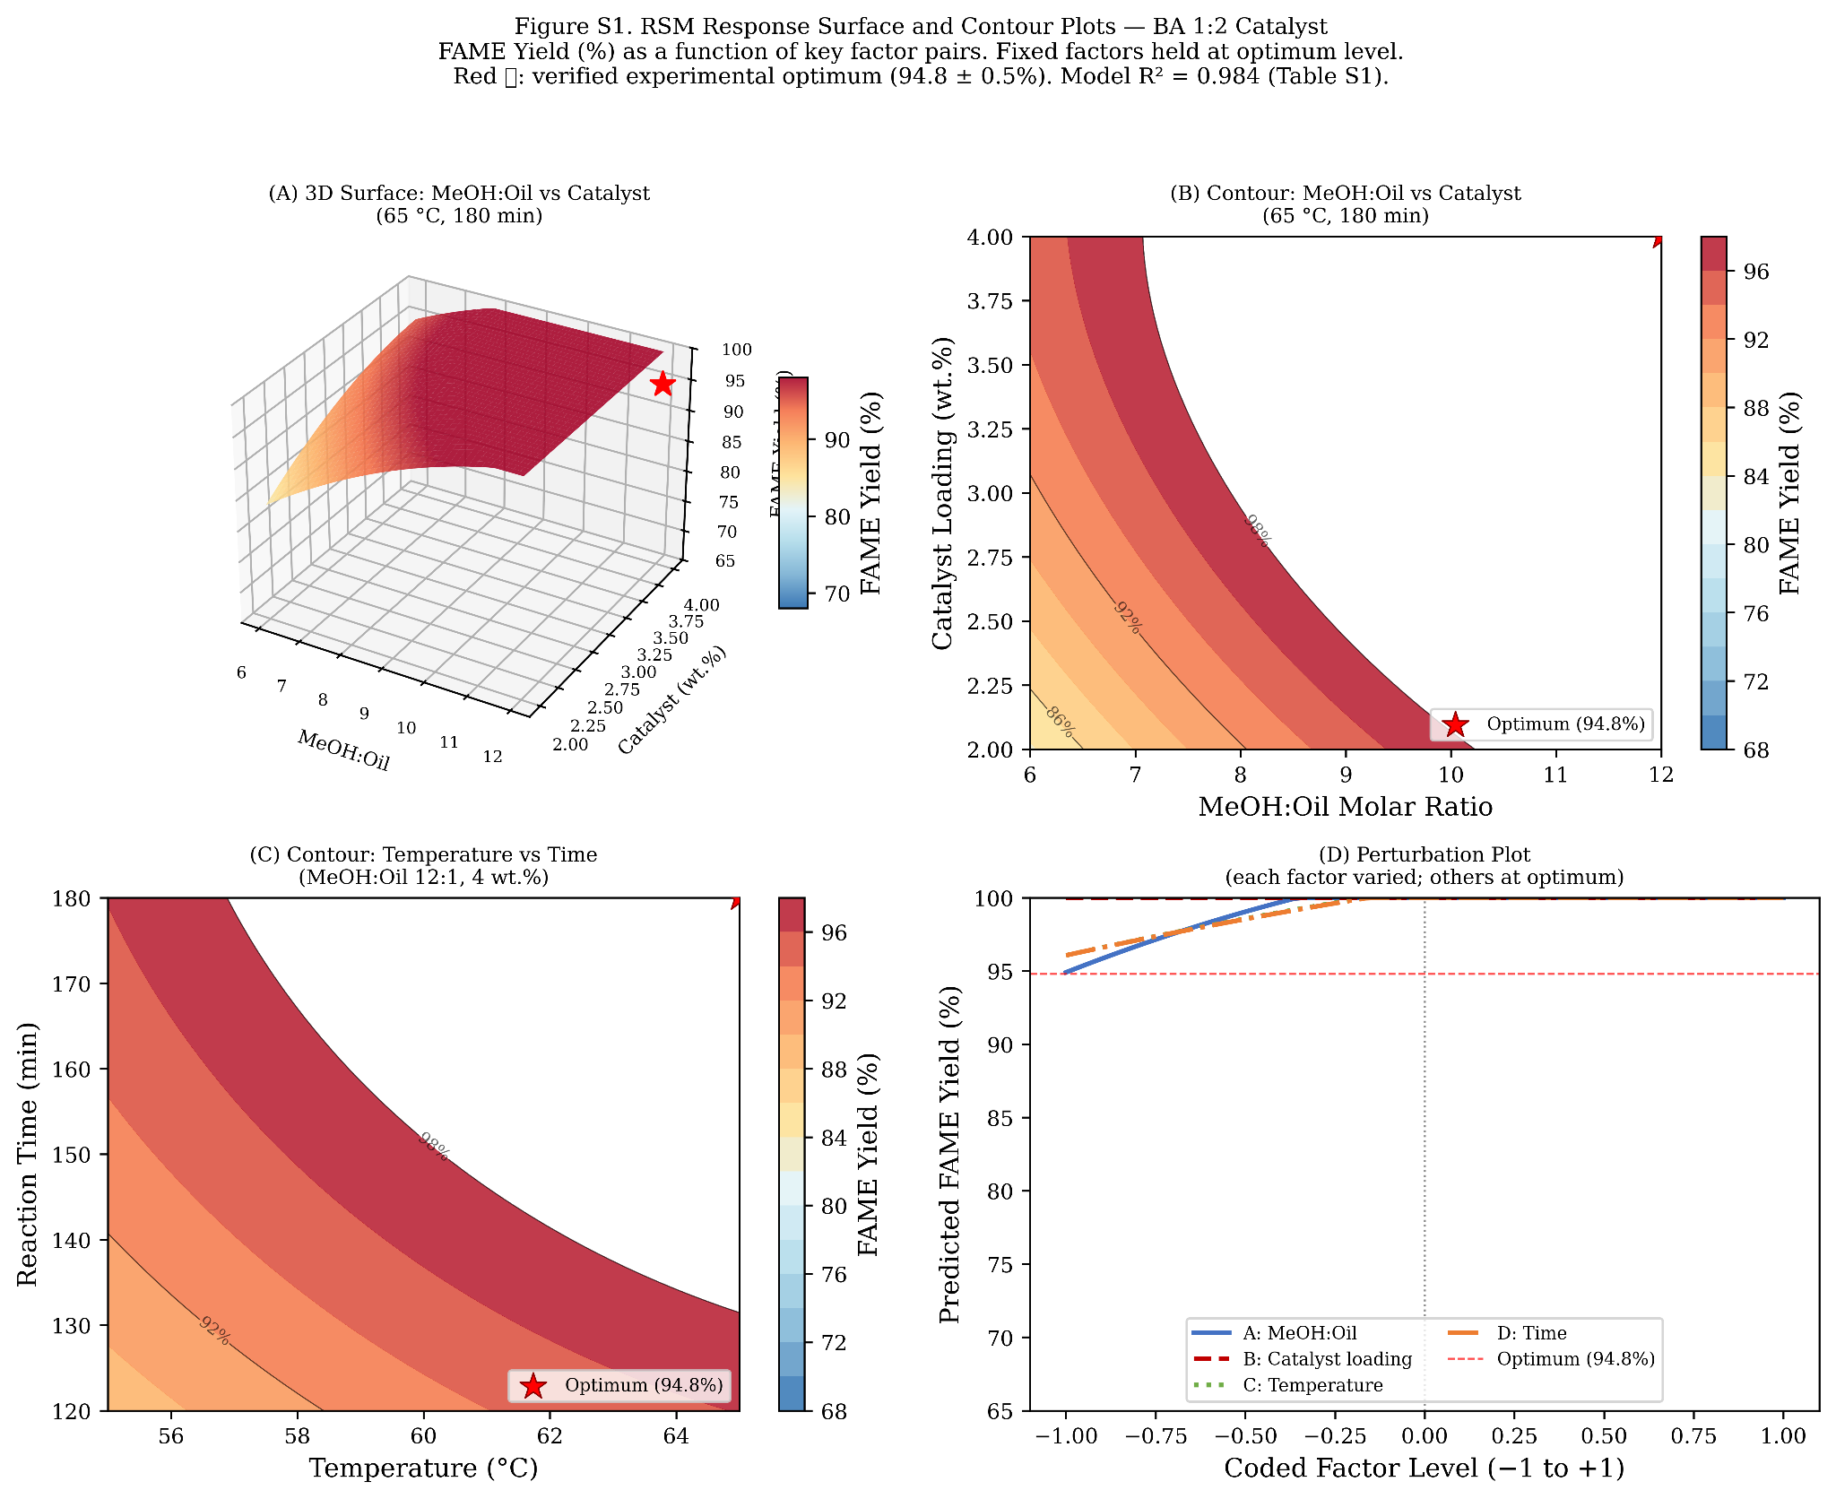
Figure S1. RSM response surface contour plot of FAME yield (%) as a function of methanol:oil molar ratio and catalyst loading (BA 1:2, 65 °C, 180 min). Red star: verified experimental optimum (94.8 ± 0.5%). Contour intervals: 2% FAME yield. Model: R² = 0.984; p < 0.001 (Table S1).

Figure S2. BJH Pore Size Distribution
The BJH desorption pore size distribution (dV/d log D vs. pore diameter) for all four catalyst variants is shown in Figure S2. All catalysts show a mesoporous distribution centred near 15 nm. The progressive increase in distribution breadth from FA to BA 1:2 is consistent with the hierarchical pore structure formed by interpenetration of the RHA microporous silica network with the FA aluminosilicate matrix, as discussed in Section 3.1 of the main text.

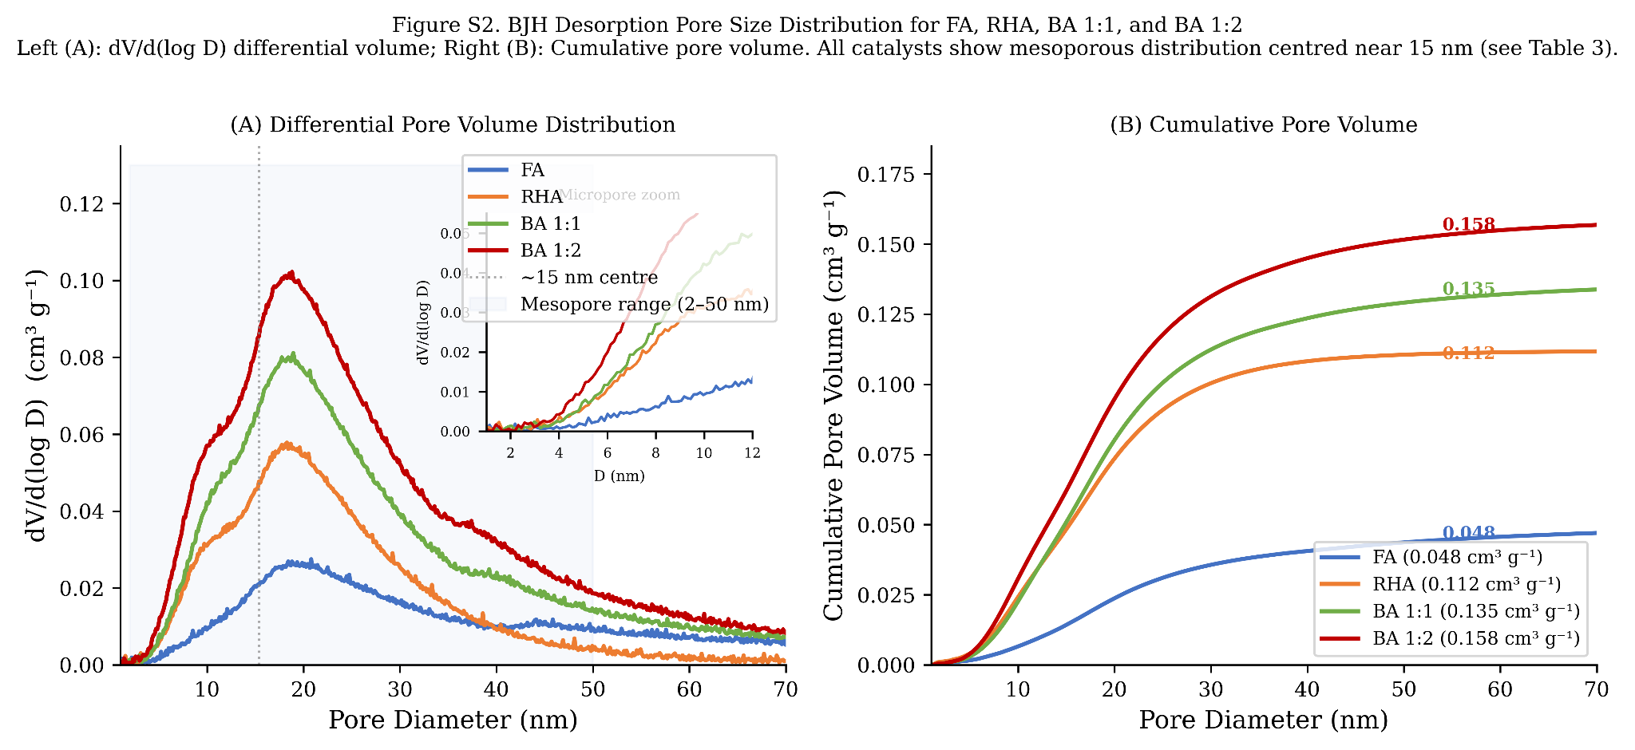
Figure S2. BJH desorption pore size distribution for FA, RHA, BA 1:1, and BA 1:2. All variants show mesoporous distributions centred near 15 nm (see Table 3, main text). Increasing distribution area from FA to BA 1:2 reflects progressive surface area development upon binary blending.

Figure S3. Individual Arrhenius Plots
Figure S3 presents individual Arrhenius plots [ln(k) vs. 1/T × 10³] for all four catalysts with regression statistics. The linearity of each plot (R² ≥ 0.990) confirms that the pseudo-first-order model and Arrhenius treatment are internally consistent across the 55–65 °C temperature range investigated. BA 1:2 shows the steepest negative slope (i.e., lowest Eₐ); RHA shows the shallowest.

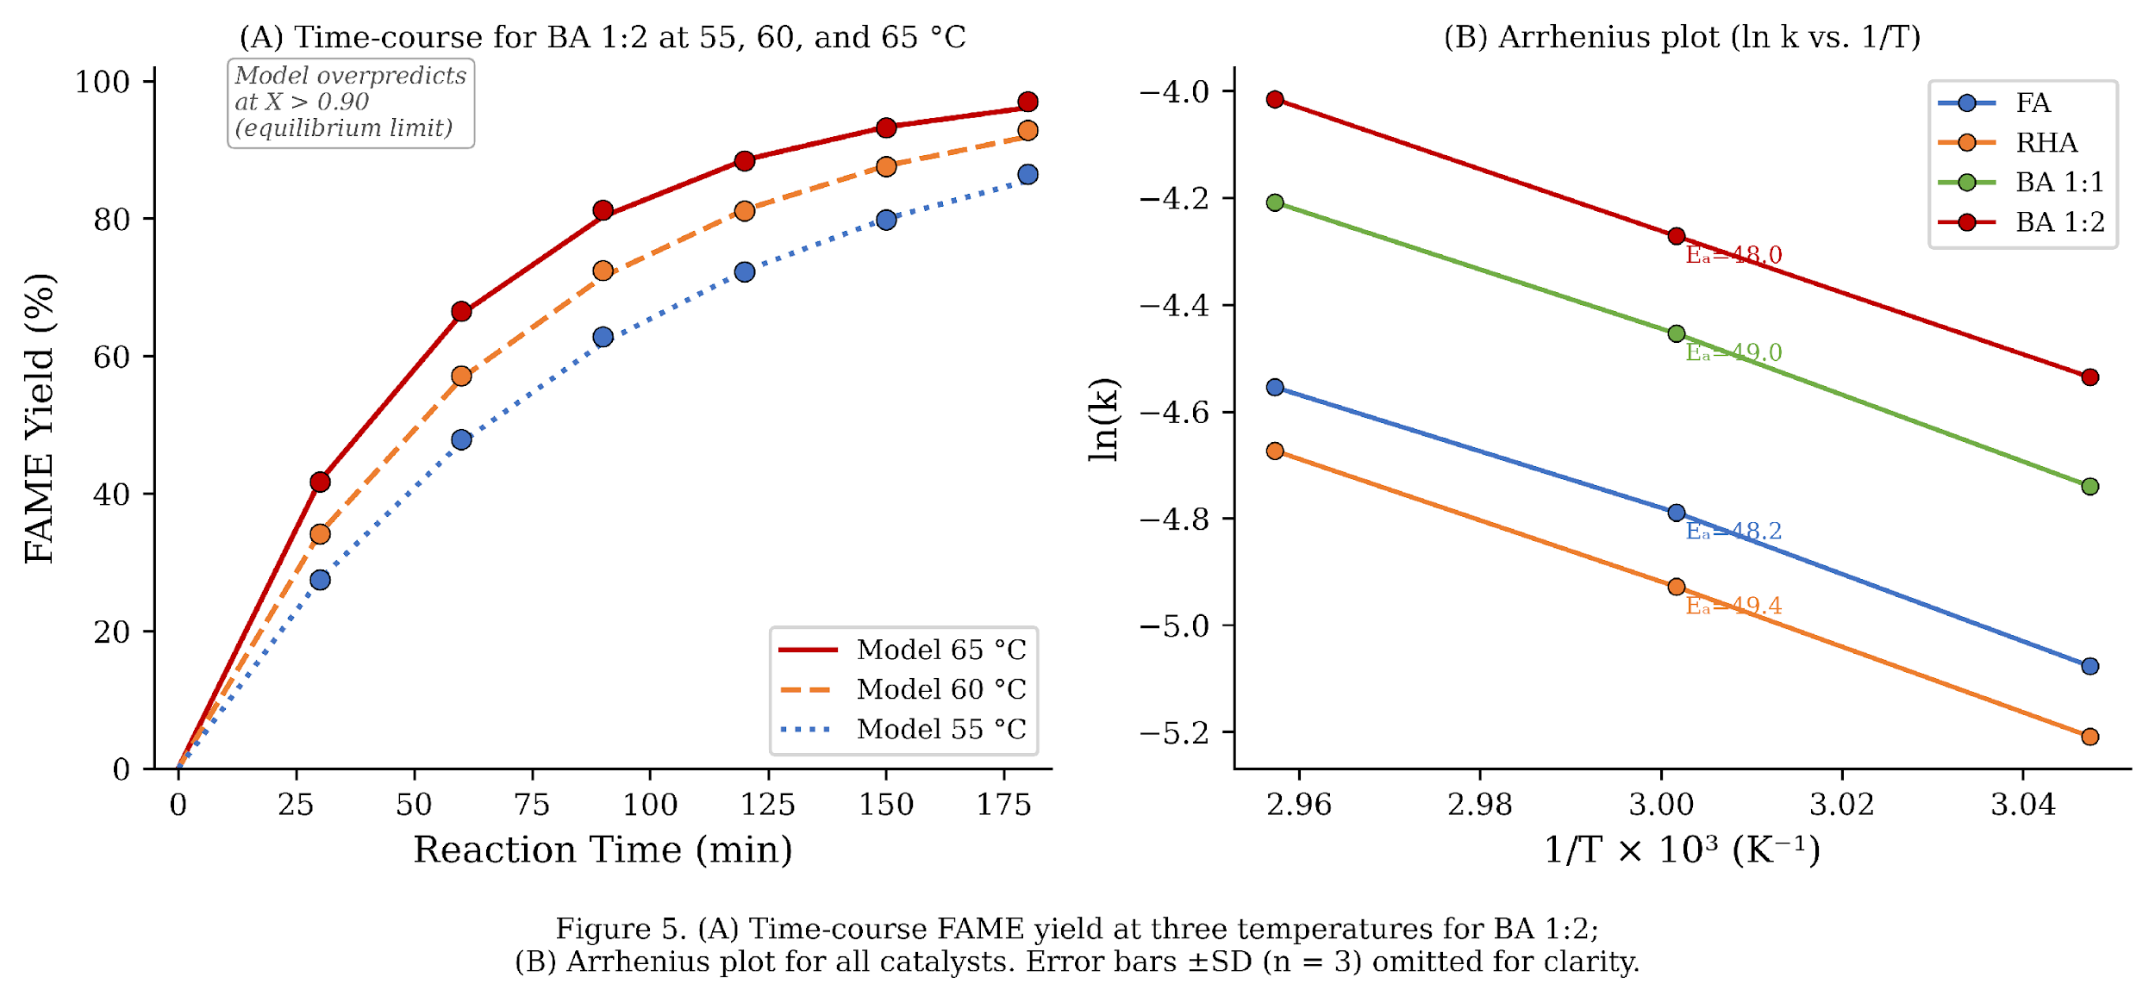
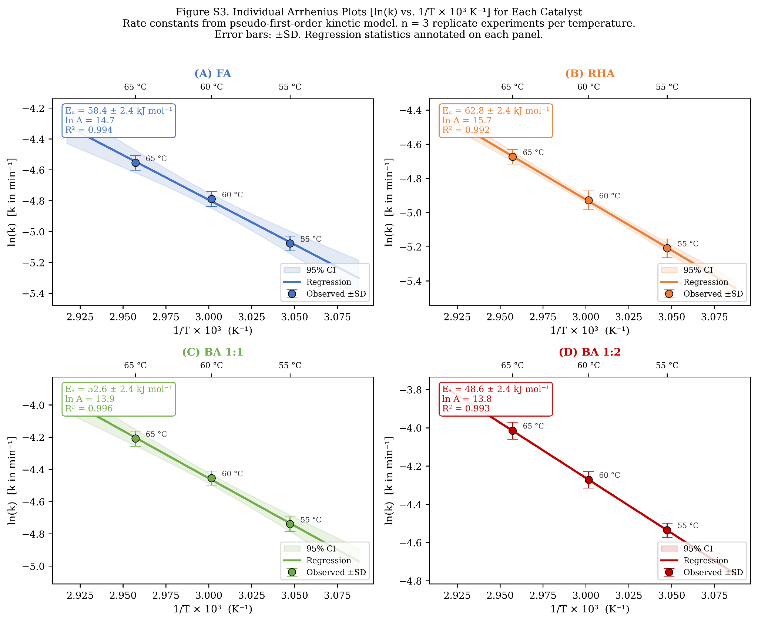
Figure S3. Individual Arrhenius plots [ln(k) vs. 1/T × 10³ K⁻¹] for (A) FA, (B) RHA, (C) BA 1:1, and (D) BA 1:2. Dashed lines: linear regression fits. Slopes give −Eₐ/R. Regression statistics (R², 95% CI on slope) annotated. n = 3 replicate kinetic experiments per catalyst per temperature.

SUPPLEMENTARY METHODS: INSTRUMENT CALIBRATION DETAILS

GC-MS FAME Quantification
FAME yield was quantified by GC-MS (Shimadzu QP2010 Ultra) using an HP-88 capillary column (100 m × 0.25 mm × 0.20 μm). Injection volume: 1 μL (split ratio 50:1). Carrier gas: He (99.999%, 1.2 mL min⁻¹). Temperature programme: 140 °C (5 min) → 240 °C (4 °C min⁻¹, 15 min hold). Methyl heptadecanoate (C17:0 methyl ester, Sigma-Aldrich, ≥99.5%) was used as the internal standard at 5 mg mL⁻¹ in heptane. A five-point external calibration curve was constructed from certified FAME reference mix (Supelco 47885-U; R² ≥ 0.9999 for each FAME component). Yield was calculated per EN 14103:2020. Repeatability (RSD): <0.5% across triplicate injections.

ICP-OES Calibration
Active metal concentrations were determined by ICP-OES (Agilent 5110 SVDV) following microwave-assisted acid digestion (USEPA Method 3052; Anton Paar Multiwave GO; 220 °C, 60 bar, 30 min). Multi-element calibration standards (1, 5, 10, 25, 50 mg L⁻¹; Merck Certipur) prepared in 2% HNO₃ matrix match. Internal standard: Sc (10 mg L⁻¹) for drift correction. Certified reference material: NIST SRM 1633c (coal fly ash); recovery 97.2–103.1% for K, Ca, Fe, Mg. Detection limits: K 0.01 mg L⁻¹; Ca 0.02 mg L⁻¹; Fe 0.01 mg L⁻¹. Expanded uncertainty U (k = 2) < 2% for all reported values.

CO₂-TPD Calibration
TCD signal was calibrated using certified CO₂ pulse calibration loops (0.500 mL ± 0.005 mL; Micromeritics; 99.999% CO₂, Linde). A six-point calibration was performed at the start of each analysis series; linearity verified (R² ≥ 0.9998). Instrument baseline stability was checked against an inert SiO₂ reference standard before each run. Intraday repeatability: RSD < 1.8% (n = 3 repeat measurements of RHA reference). Day-to-day reproducibility: RSD < 2.4% across three separate analysis days.

— End of Supplementary Information —

